**Story**

|  |  |
| --- | --- |
| Date | 20 March 2025 |
| Team ID | LTVIP2025TMID26725 |
| Project Name | Visualization Tool for Electric Vehicle Charge and Range Analysis |
| Maximum Marks | 5 Marks |

By using stories in Tableau, you can effectively communicate complex data in a way that is both interactive and engaging, making it easier for the audience to follow along and understand the insights. It’s a tool for data storytelling, allowing you to present insights in a cohesive, engaging way that takes viewers through a logical progression of findings or analyses.

In Tableau, Story is a feature that allows you to create a sequence of dashboards, visualizations, and text to present data insights in a cohesive and narrative-driven way. It's like a slideshow within Tableau that guides the audience through a series of data points, helping them understand key insights, trends, or outcomes of your analysis.

**Overview of the Story**

This story provides an in-depth analysis of electric vehicle (EV) pricing across various models and segments. It visualizes the cost distribution, highlighting premium, mid-range, and budget-friendly EVs.

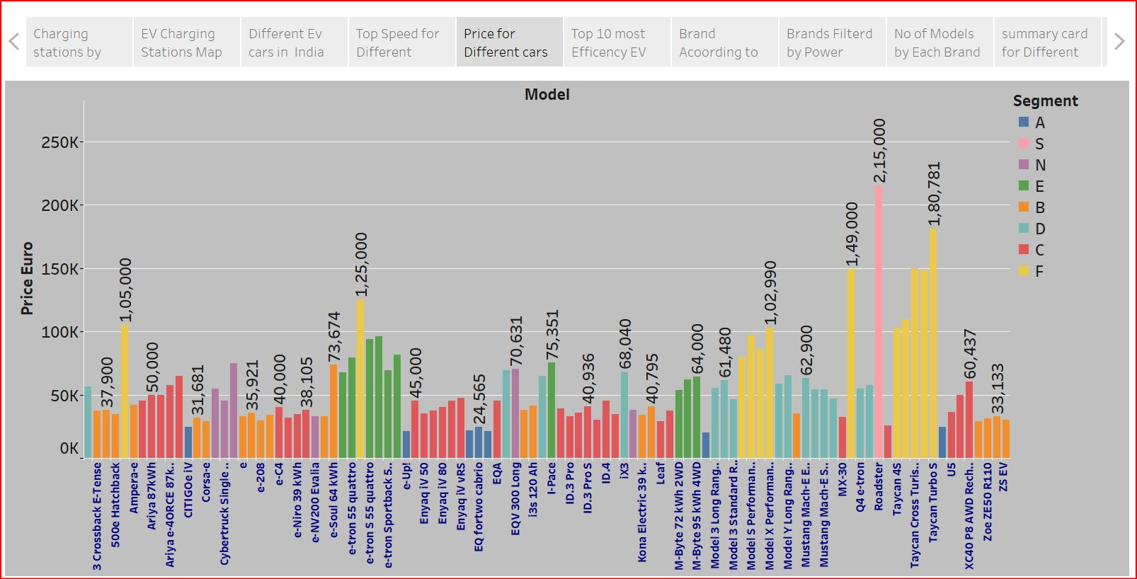

**Key Observations and Insights**

* **Pricing Trends Across EV Models**
* Prices range from €33,133 (Z5 EV) to €215,000 (Taycan Turbo S).
* The Taycan Turbo S (€180,781) and Roadster (€149,000) are among the highest-priced models.
* The most affordable EVs include the Corsa-e (€31,681) and 500e Hatchback (€37,900).
* **Segmentation of EVs**
* The models are categorized into different segments (A, S, N, E, B, D, C, F).
* The luxury segment (F) features high-end models like Taycan Turbo S and Roadster.
* Budget-friendly EVs belong to segment B and C, making them more accessible.
* **Mid-Range and Premium Models**
* Audi e-tron Sportback 55 (€125,000) is positioned in the premium category.
* Enyaq IV 50 (€45,000) and ID.3 Pro (€40,936) fall in the mid-range category.
* **Price Distribution across Manufacturers**
* Volkswagen, Audi, Porsche, and Tesla dominate the higher price ranges.
* Peugeot, Citroen, and Hyundai offer more affordable EVs.

**Story Progression and Narrative**

**Introduction:** Displaying the price distribution of different EV models.

**Segmentation:** Highlighting categories of EVs based on pricing.

**Luxury vs. Budget:** Comparing high-end vs. affordable models.

**Key Brand Insights:** Identifying dominant manufacturers in each price range.

**Conclusion:** Summarizing the affordability spectrum of EVs for different consumer segments.

**Final Takeaways**

* Luxury EVs are significantly more expensive, with a €100K+ price difference from budget EVs.
* Mid-range EVs (priced €40K - €70K) are widely available, offering balanced features.
* The budget segment is ideal for new adopters looking for cost-effective electric mobility.